Total Ballots Cast: 440 Registered Voters: 6089 Overall Turnout: 7.23%
1
1
Choice Votes Vote% All Precincts
Mayor - City of Jackson (R) (Vote for 1)
ERIC G. BROWN 141 46.69%
RANDY EVANS 161 53.31% Total 302 100.00%

President of Council - City of Jackson (R) (Vote for 1)
CARISA EDWARDS | 148 | 100.00%
Total | 148 | 100.00%

Auditor - City of Jackson (R) (Vote for 1)
BRETT E. REED | 212 | 100.00%
Total | 212 | 100.00%

Council at Large - City of Jackson (R) (Vote for 3)
MARVA COLBY | 127 | 41.50%
BRETT FOSTER | 179 | 58.50%
Total | 306 | 100.00%

Mayor• City of Wellston (R) (Vote for 1) CHARLES D. HUDSON 59 100.00% Total 59 100.00%

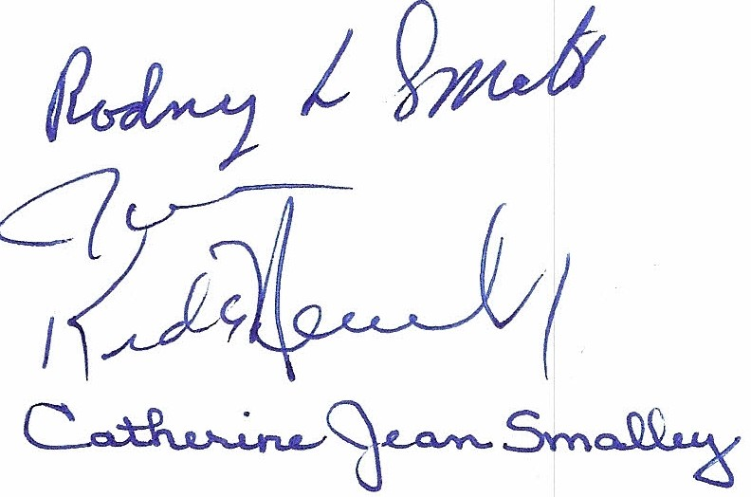
President of Council - City of Wellston (R) (Vote for 1)
CONNIE PELLETIER | 38 | 100.00%
Total | 38 | 100.00%

Auditor - City of Wellston (R) (Vote for 1)
ALICIA A. BEATTY | 16 | 24.24%
GARY L. CRABTREE | 39 | 59.09%
CHRIS DUPREE 11 16.67%

Total 66
Director of Law - City of Wellston (R) (Vote for 1)
100.00%

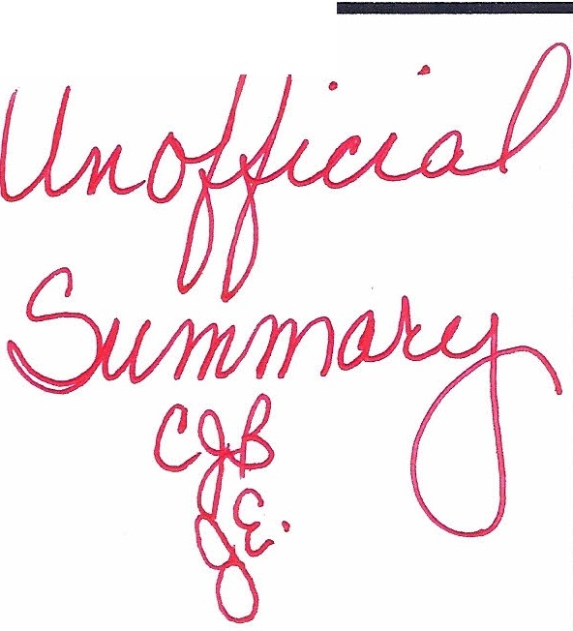
RANDY DUPREE | 52 | 100.00%
Total | 52 | 100.00%

Council at Large - City of Wellston (R) (Vote for 3)
TOM CLARK | 53 | 100.00%
Total | 53 | 100.00%

Ward Council J1 - City of Jackson (R) (Vote for 1)
J. RYAN PETERS | 66 | 100.00%
Total | 66 | 100.00%

Ward Council J2 - City of Jackson (R) (Vote for 1)
JOHN PETERS | 16 | 100.00%
Total | 16 | 100.00%

Ward Council J3 - City of Jackson (R) (Vote for 1)
DEBORAH BIGGS | 27 | 100.00%
Total | 27 | 100.00%

Ward Council J4 • City of Jackson (R) (Vote for 1)
TIM MATCHETT | 78 | 100.00%
Total | 78 | 100.00%

Total Ballots Cast: 4401 Registered Voters: 60891 Overall Turnout: 7.23%
Choice Votes Vote % Ward Council W1 - City of Wellston (R) (Vote for 1)
TERESA PONN-LEMASTER | 3 | 27.27%
D. KEITH WOOLUM | 8 | 72.73%
Total | 11 | 100.00%

Ward Council W3 - City of Wellston (R) (Vote for 1)
O 6
SAM CLARK |  | 0.00%
RICK HUDSON |  | 100.00%
Total |  | 100.00%

6

Ward Council W4 - City of Wellston (R) (Vote for 1)
ANTHONY BRENNER | 13 | 100.00 %
Total | 13 | 100.00%

Proposed Tax Levy (Additional) Village of Coalton (Vote for 1), 323 registered voters, turnout 0.62%
O
For the Tax Levy |  | 0.00%
Against the Tax Levy |  | 100.00%
Total |  | 100.00%

2
2

Proposed Tax Levy (Additional) Jackson Township (Vote for 1), 850 registered voters, turnout 3.88%
For the Tax Levy | 3 | 9.09%
Against the Tax Levy | 30 | 90.91%
Total | 33 | 100.00 %

Proposed Tax Levy (Renewal) Lick Township (Vote for 1), 1675 registered voters, turnout 1.43%
For the Tax Levy | 23 | 95.83%
Against the Tax Levy | 1 | 4.17%
Total | 24 | 100.00%

Proposed Tax Levy (Renewal) City of Wellston (Vote for 1), 3241 registered voters, turnout 2.31%
For the Tax Lev y | 49 | 65.33%
Against the Tax Levy | 26 | 34.67%
Total | 75 | 100.00%

